PAR Check Out

PAR T/A, T/B, Book, Auction, Trade/Fill, Cancel & Cancel/Replace

Test Plan

Wege Kifle
ITG
Table of Contents
Test Setting 3
Simple Order 4
PAR Book Request, Trade with Book (T/B) & Trade with All (T/A) 4
Test Case 1. Verify that Simple order is routed from SBT to PAR only when Product is in Open or Fast State 4
Test Case 2. Simple Limit order is routed from PAR to SBT with BOOK Request (Auction) 5
Test Case 3. Simple Limit order is routed from PAR to SBT with BOOK Request (no Auction) 6
Test Case 4. Simple Limit order is routed from PAR to SBT with Trade with Book (T/B) Request 6
Test Case 5. Simple Limit order is routed from PAR to SBT with Trade with All (T/A) Request 7
Test Case 6.Simple Contingency orders are routed from PAR to SBT with Trade with All (T/A) Request 7
Test Case 7.Simple Contingency orders are routed from PAR to SBT with Trade with Book (T/B) Request 10
Test Case 8.Simple Contingency orders are routed from PAR to SBT with BOOK Request 13
Trade/Fill Report, Cancel Report, Cancel/Replace Report, & Cancel Request 16
Test Case 9. Simple Limit & MKT orders trade fully on PAR, Verify CMI user receives Trade/Fill Report 16
Test Case 10. Simple Limit and MKT orders are routed to PAR, Verify CMI user receives Cancel Report 16
Test Case 11. Simple Limit and MKT orders are routed to PAR, Verify CMI user Sends a Cancel Request to PAR 17
Test Case 12. Simple Limit order is routed to PAR, Verify CMI user sends a Cancel/Replace Request to PAR 17
Complex Order 19
PAR Trade with All (T/A), Auction, & Book Request 19
Test Case 13. Verify that Complex Order is order is routed from SBT to PAR when product is in the following State 19
Test Case 14. Complex Limit order is routed from PAR to SBT with Trade with All (T/A) Request 20
Test Case 15. Complex Limit order is routed from PAR to SBT with Book Request 21
Test Case 16. Complex Limit order is routed from PAR to SBT with Auction Request 22
Trade/Fill Report, Cancel Report, Cancel/Replace Report, & Cancel Request 24
Test Case 17. Complex Limit & MKT order trades on PAR, Verify CMI user receives trade/fill report for the legs and complex order 24
Test Case 18. Complex Limit & MKT order is routed to PAR, Verify CMI user receives cancel report for full qty when order is fully canceled by PAR broker 24
Test Case 19. Complex Limit order is routed to PAR, CMI user sends a Cancel Request to PAR 25
Test Case 20. Complex Limit order is routed to PAR, CMI user sends a Cancel/Replaced request to PAR 26
Appendix – TPF settings 27

Test Setting

Option Class Trading Property Setting

- Auction Enabled to FALSE for all Auction types EXCEPT for HAL (unless otherwise specified in the test case)
- Auction Min Max Order Size to 1(lower limit) and 10000(upper limit) for all Auction types
- Auction Min Number Of Quoters to 1 for all Auction types
- Auction Min Price Increment to 1 for all Auction types
- Auction Minimum Order Size For Ticks Above NBBO to 1 for all Auction types except for HAL; HAL is 99999
- Auction Order Ticks Away From NBBO to 1 for all Auction types
- Auction Receiver Type to 1-ClassQuoter for all Auction types
- Auction Time To Live to value that will be long enough to execute your test events before auction expires for all Auction types
- Allowed HAL types to 1:NBBOReject, 2:Tweener_Lock, & 3:Tweener
- Enable BOTR Calculation to TRUE for all Auction types
- MOC Interval Seconds to a time to trigger order immediately (unless otherwise specified in the test case)

Strategy Class Trading Property Setting

- Allow Market Order to TRUE
- Auction Enabled to TRUE for Auction type 2 (COA) (unless otherwise specified in the test case)
- Auction Time To Live to value that will be long enough to execute your test events before auction expires for COA
- Auction Min Max Order Size to 1(lower limit) and 10000(upper limit) for COA
- Auction Min Number Of Quoters to 1 for COA
- Auction Min Price Increment to 1 for all COA
- Auction Receiver Type to 1-ClassQuoter for COA
- Make sure that ALL users are subscribed for auction in order to enter RFPs and to participate in the Auction.
- Make sure the order book for the product is empty before testing each Test Cases/Scenarios. (Unless otherwise specified in the test case)
- Make sure your routing table is setup to route orders From SBT to the specified Destination
- Test Plan needs to be executed in Hybrid session only
- Before executing the test plan, choose a class, pick up a product and put the product in a trading open state unless otherwise stated in the case
- Verifications of Received Filled or Cancelled Reports can be done in the Status Window of the Trader Gui or by checking the Book Depth or Current Market
- Make Sure All orders are originated from CMI (Unless otherwise Specified)

Simple Order

PAR Book Request, Trade with Book (T/B) & Trade with All (T/A)

Test Case 1 Verify that Simple order is routed from SBT to PAR only when Product is in Open or Fast State

- Set product to Suspended
- CUST1 Enters Order ‘C’: Buy 100@1.20
- Verify that Entry is not allowed from Trader GUI
- Set product to Closed
- CUST1 Enters Order ‘C’: Buy 100@1.20
    - Verify that order is rejected by OHS, CD System Error
- Set product to Pre-Open:
- MM1 Enters Quote: 1.00 x 100 – 1.20 x 100
- CUST1 Enters Order ‘C’: Buy 10@1.20
- CUST2 Enters Order ‘C’ Buy 20@MKT
    - Verify that order is accepted and booked, Current Market 1.20 x 10 – 1.20 x 100
- Set product to Opening Rotation:
- CUST1 Enters Order ‘C’: Buy 50@1.10 (before product opens)
    - Verify that order is accepted and booked, Current Market 1.20 x 10 – 1.20 x 100
    - After Product Opens, Verify that CUST1 order trades with quote 10@1.20 & CUST2 order trades with quote 20@1.20
    - Verify CBOE Current Market: 1.10 x 50 – 1.20 x 70
- Verify that product is Open:
- CUST1 Enters Order ‘C’: Buy 70@1.10
    - Verify that CUST1’s order is routed to PAR
    - Verify CBOE Current Market: 1.10 x 50 – 1.20 x 70
- Set product to Fast:
- CUST1 Enters Order ‘C’: Sell 70@1.10
    - Verify that CUST1’s order is routed to PAR
    - Verify CBOE Current Market: 1.10 x 50 – 1.20 x 70
- Set product to Halt:
- CUST1 Enters Order ‘C’: Sell 70@1.10
    - Verify that MM1 quote is canceled and CUST1 order is accepted & routed to Booth
    - Verify CBOE Current Market: 1.10 x 50 – 0.00 x 0

Test Case 2 Simple Limit order is routed from PAR to SBT with BOOK Request (Auction)

NBBO Reject
- NBBO: 1.00 x 50 – 1.15 x 50
- MM1 Enters Quote: 1.00 x 100 – 1.20 x 100
- CUST1 Enters Order ‘C’: Buy 100@1.20
- Verify order is accepted & routed to PAR
    - Verify CBOE Current Market: 1.00 x 100 – 1.20 x 100
- PAR broker sends the order from PAR to SBT using BOOK
    - Verify that HAL Auction starts 100@1.15
Result:
- After Auction is expired, verify that order trades with MM1 quote 50@1.20, the remaining 50 is routed back to PAR
- Verify Current Market: 1.00 x 100 – 1.20 x 50 & Verify Last Sale 50@1.20

Tweener
- NBBO: 1.00 x 50 – 1.15 x 50
- MM1 Enters Quote: 1.00 x 100 – 1.20 x 100
- CUST1 Enters Order ‘C’: Buy 100@1.10
- Verify order is accepted & routed to PAR
    - Verify CBOE Current Market: 1.00 x 100 – 1.20 x 100
- PAR broker sends the order from PAR to SBT using BOOK
    - Verify that HAL Auction starts 100@1.10
Result:
- After Auction is expired, verify that order is booked
- Verify Current Market: 1.10 x 100 – 1.20 x 100

Test Case 3 Simple Limit order is routed from PAR to SBT with BOOK Request (no Auction)

- NBBO: 1.00 x 50 – 1.20 x 50
- MM1 Enters Quote: 1.00 x 50 – 1.20 x 50
- CUST1 Enters Order ‘C’: Buy 100@1.20
- Verify order is accepted & routed to PAR
    - Verify CBOE Current Market: 1.00 x 50 – 1.20 x 50
- PAR broker sends the order from PAR to SBT using BOOK
Result:
- Verify that order trades with MM1 quote 50@1.20, the remaining 50 is routed back to PAR
- Verify Current Market: 1.00 x 50 – 0.00 x 0 & Verify Last Sale 50@1.20

Test Case 4 Simple Limit order is routed from PAR to SBT with Trade with Book (T/B) Request

- NBBO: 1.00 x 50 – 1.20 x 50
- MM1 Enters Quote: 1.00 x 50 – 1.20 x 50
- CUST1 Enters Order ‘C’: Buy 50@1.20
- Verify order is accepted & routed to PAR
- MM2 Enters Order ‘I’: Sell 50@1.10
- CUST2 Enters Order ‘D’ Sell 30@1.10
    - Verify CBOE Current Market: 1.00 x 50 – 1.10 x 80
- PAR broker sends the order from PAR to SBT using T/B
Result:
- Verify that order trades ONLY with CUST2 order 30@1.10, the remaining 20 is routed back to PAR
- Verify Current Market: 1.00 x 50 – 1.10 x 50 & Verify Last Sale 30@1.10

Test Case 5 Simple Limit order is routed from PAR to SBT with Trade with All (T/A) Request

- NBBO: 1.00 x 50 – 1.20 x 50
- MM1 Enters Quote: 1.00 x 50 – 1.20 x 50
- MM2 Enters Order ‘I’: Sell 50@1.20
- CUST1 Enters Order ‘D’ Sell 30@1.20
    - Verify CBOE Current Market: 1.00 x 50 – 1.20 x 130
- CUST2 Enters Order ‘C’: Buy 150@1.20
    - Verify order is accepted & routed to PAR
- PAR broker sends the order from PAR to SBT using T/A
Result:
- Verify that order trades with CUST1order 30@1.20, MM2 order 50@1.20, & Quote 50@1.20, the remaining 20 is routed back to PAR
- Verify Current Market: 1.00 x 50 – 0.00 x 0 & Verify Last Sale 130@1.20

Test Case 6Simple Contingency orders are routed from PAR to SBT with Trade with All (T/A) Request

Contingency AON Order
- BOTR: 1.00 x 100 – 1.15 x 100
- MM1 Enters Quote: 1.00 x 50 – 1.20 x 50
- MM2 Enters Order ‘I’: Buy 50@1.10
    - Verify CBOE Current Market: 1.10 x 50 – 1.20 x 50
- CUST2 Enters Order AON ‘C’: Sell 100@1.00, direct route to PAR workstation
    - Verify order is accepted & routed to PAR
- PAR broker sends the order from PAR to SBT using T/A
Result:
- Verify that order trades with MM2 I order 50@1.10, & the remaining 50 is routed back to PAR
- Verify Current Market: 1.00 x 50 – 1.20 x 50 & Verify Last Sale 50@1.10

Contingency FOK Order
- BOTR: 1.00 x 100 – 1.15 x 100
- MM1 Enters Quote: 1.00 x 50 – 1.20 x 50
- MM2 Enters Order ‘I’: Sell 50@1.20
    - Verify CBOE Current Market: 1.00 x 50 – 1.20 x 100
- CUST2 Enters Order FOK ‘C’: Buy 150@1.20, direct route to PAR workstation
    - Verify order is accepted & routed to PAR
- PAR broker sends the order from PAR to SBT using T/A
Result:
- Verify that order trades with MM2 I order 50@1.20, & Quote 50@1.20, the remaining 50 is routed back to PAR
- Verify Current Market: 1.00 x 50 – 0.00 x 0 & Verify Last Sale 100@1.20

Contingency IOC Order
- BOTR: 1.00 x 100 – 1.15 x 100
- MM1 Enters Quote: 1.00 x 50 – 1.20 x 50
- MM2 Enters Order ‘I’: Buy 50@1.00
    - Verify CBOE Current Market: 1.00 x 100 – 1.20 x 50
- CUST2 Enters Order IOC ‘C’: Sell 150@1.00, direct route to PAR workstation
    - Verify order is accepted & routed to PAR
- PAR broker sends the order from PAR to SBT using T/A
Result:
- Verify that order trades with MM2 I order 50@1.00, & Quote 50@1.00, the remaining 50 is routed back to PAR
- Verify Current Market: 0.00 x 0 – 1.20 x 50 & Verify Last Sale 100@1.00

Contingency STP Order
- BOTR: 1.00 x 100 – 1.15 x 100
- MM1 Enters Quote: 1.00 x 50 – 1.20 x 50
- MM2 Enters Order ‘I’: Sell 30@1.20
    - Verify CBOE Current Market: 1.00 x 50 – 1.20 x 80
- CUST2 Enters Order STP ‘C’: Buy 100@MKT, STP price 1.00
    - Verify that Auction stats 100@1.15 and order is routed to PAR after auction is expired
- PAR broker sends the order from PAR to SBT using T/A
Result:
- Verify that order trades with MM2 I order 30@1.20, & Quote 50@1.20, the remaining 20 is routed back to PAR
- Verify Current Market: 1.00 x 50 – 0.00 x 0 & Verify Last Sale 80@1.20

Contingency STP_LMT Order
- BOTR: 1.10 x 100 – 1.15 x 100
- MM1 Enters Quote: 1.00 x 50 – 1.20 x 50
- MM2 Enters Order ‘I’: Buy 20@1.00
    - Verify CBOE Current Market: 1.00 x 70 – 1.20 x 50
- CUST2 Enters Order STP_LMT ‘C’: Sell 100@1.00, STP price 1.20
    - Verify that Auction stats 100@1.10 and order is routed to PAR after auction is expired
- PAR broker sends the order from PAR to SBT using T/A
Result:
- Verify that order trades with MM2 I order 20@1.00, & Quote 50@1.00, the remaining 30 is routed back to PAR
- Verify Current Market: 0.00 x 0 – 1.20 x 50 & Verify Last Sale 70@1.00

Contingency MOC Order
- BOTR: 1.05 x 100 – 1.15 x 100
- MM1 Enters Quote: 1.00 x 50 – 1.20 x 50
- MM2 Enters Order ‘I’: Buy 50@1.00
    - Verify CBOE Current Market: 1.00 x 100 – 1.20 x 50
- CUST2 Enters Order MOC ‘C’: Sell 150@MKT,
    - Verify that Auction stats 150@1.05
    - After Auction is expired 100 order qty route to PAR and 50 order qty trades with MM2 order 50@1.00
- PAR broker sends the order from PAR to SBT using T/A
Result:
- Verify that order trades with Quote 50@1.00, the remaining 50 is routed back to PAR
- Verify Current Market: 0.00 x 0 – 1.20 x 50 & Verify Last Sale 50@1.00

Test Case 7Simple Contingency orders are routed from PAR to SBT with Trade with Book (T/B) Request

Contingency AON Order
- BOTR: 1.00 x 100 – 1.15 x 100
- MM1 Enters Quote: 1.00 x 50 – 1.20 x 50
- MM2 Enters Order ‘I’: Buy 10@1.10
- CUST1 Enters Order ‘C’ Buy 30@1.10
    - Verify CBOE Current Market: 1.10 x 40 – 1.20 x 50
- CUST2 Enters Order AON ‘C’: Sell 100@1.00, direct route to PAR workstation
    - Verify order is accepted & routed to PAR
- PAR broker sends the order from PAR to SBT using T/B
Result:
- Verify that order trades with CUT1 order 30@1.10, & the remaining 70 is routed back to PAR
- Verify Current Market: 1.10 x 10 – 1.20 x 50 & Verify Last Sale 30@1.10

Contingency FOK Order
- BOTR: 1.00 x 100 – 1.15 x 100
- MM1 Enters Quote: 1.00 x 50 – 1.20 x 50
- MM2 Enters Order ‘I’: Sell 50@1.20
- CUST1 Enters Order ‘C’ Sell 50@1.20
    - Verify CBOE Current Market: 1.00 x 50 – 1.20 x 150
- CUST2 Enters Order FOK ‘C’: Buy 100@1.20, direct route to PAR workstation
    - Verify order is accepted & routed to PAR
- PAR broker sends the order from PAR to SBT using T/B
Result:
- Verify that order trades with CUST1 order 50@1.20, the remaining 50 is routed back to PAR
- Verify Current Market: 1.00 x 50 – 1.20 x 100 & Verify Last Sale 50@1.20

Contingency IOC Order
- BOTR: 1.00 x 100 – 1.15 x 100
- MM1 Enters Quote: 1.00 x 50 – 1.20 x 50
- MM2 Enters Order ‘I’: Buy 50@1.00
- CUST1 Enters Order ‘C’ Buy 10@1.00
    - Verify CBOE Current Market: 1.00 x 110 – 1.20 x 50
- CUST2 Enters Order IOC ‘C’: Sell 50@1.00, direct route to PAR workstation
    - Verify order is accepted & routed to PAR
- PAR broker sends the order from PAR to SBT using T/B
Result:
- Verify that order trades with CUST1 order 10@1.00, the remaining 40 is routed back to PAR
- Verify Current Market: 1.00 x 100 – 1.20 x 50 & Verify Last Sale 10@1.00

Contingency STP Order
- BOTR: 1.00 x 100 – 1.15 x 100
- MM1 Enters Quote: 1.00 x 50 – 1.20 x 50
    - Verify CBOE Current Market: 1.00 x 50 – 1.20 x 50
- CUST2 Enters Order STP ‘C’: Buy 100@MKT, STP price 1.00
    - Verify that Auction stats 100@1.15
- MM2 Enters Order ‘I’: Sell 30@1.20
- CUST1 Enters Order ‘C’ Sell 50@1.20
    - CUST2 order is routed to PAR after auction is expired
- PAR broker sends the order from PAR to SBT using T/B
Result:
- Verify that order trades with CUST1order 50@1.20, the remaining 50 is routed back to PAR
- Verify Current Market: 1.00 x 50 – 1.20 x 80 & Verify Last Sale 50@1.20

Contingency STP_LMT Order
- BOTR: 1.10 x 100 – 1.15 x 100
- MM1 Enters Quote: 1.00 x 50 – 1.20 x 50
    - Verify CBOE Current Market: 1.00 x 50 – 1.20 x 50
- CUST2 Enters Order STP_LMT ‘C’: Sell 100@1.00, STP price 1.20
    - Verify that Auction stats 100@1.10
- MM2 Enters Order ‘I’: Buy 20@1.00
- CUST1 Enters Order ‘C’ Buy 10@1.00
    - CUST2 order is routed to PAR after auction is expired
- PAR broker sends the order from PAR to SBT using T/B
Result:
- Verify that order trades with CUST1order 10@1.00, the remaining 90 is routed back to PAR
- Verify Current Market: 1.00 x 70 – 1.20 x 50 & Verify Last Sale 10@1.00

Contingency MOC Order
- BOTR: 1.10 x 100 – 1.15 x 100
- MM1 Enters Quote: 0.95 x 50 – 1.20 x 50
    - Verify CBOE Current Market: 0.95 x 50 – 1.20 x 50
- CUST2 Enters Order MOC ‘C’: Sell 100@MKT,
    - Verify that Auction stats 100@1.10,
- MM2 Enters Order ‘I’: Buy 50@1.00
- CUST1 Enters Order ‘C’ Buy 50@1.00
    - After Auction is expired Verify that CUST2 order is routed to PAR
- PAR broker sends the order from PAR to SBT using T/B
Result:
- Verify that order trades with CUST1order 50@1.00, the remaining 50 is routed back to PAR
- Verify Current Market: 1.00 x 50 – 1.20 x 50 & Verify Last Sale 50@1.00

Test Case 8Simple Contingency orders are routed from PAR to SBT with BOOK Request

Contingency AON Order
- BOTR: 1.10 x 50 – 1.15 x 50
- MM1 Enters Quote: 1.00 x 50 – 1.20 x 50
    - Verify CBOE Current Market: 1.00 x 50 – 1.20 x 50
- CUST1 Enters Order AON ‘C’: Sell 50@1.05, direct route to PAR workstation
    - Verify order is accepted & routed to PAR
- PAR broker sends the order from PAR to SBT using BOOK
    - Verify that HAL Auction starts AON 50@1.10
- MM2 Enters Order ‘I’: Buy 10@1.05
- CUST2 Enters Order ‘C’ Buy 40@1.05
    - Verify Current Market 1.05 x 50 – 1.20 x 50
Result:
- After Auction is expired, AON order is routed to PAR
- PAR broker sends the order from PAR to SBT using BOOK
- Verify that AON order trades for 50@1.05
- Verify Current Market: 1.00 x 50 – 1.20 x 50 & Verify Last Sale 50@1.05

Contingency FOK Order
- BOTR: 1.00 x 100 – 1.15 x 100
- MM1 Enters Quote: 1.00 x 50 – 1.20 x 50
    - Verify CBOE Current Market: 1.00 x 50 – 1.20 x 50
- CUST2 Enters Order FOK ‘C’: Buy 150@1.20, direct route to PAR workstation
    - Verify order is accepted & routed to PAR
- PAR broker sends the order from PAR to SBT using BOOK
- Verify that HAL Auction starts FOK 150@1.15,
- MM2 Enters Order ‘I’: Sell 50@1.20
- CUST1 Enters Order ‘C’ Sell 50@1.20
    - Verify CBOE Current Market: 1.00 x 50 – 1.20 x 150
Result:
- After Auction is expired, full FOK order qty is cancelled
- Verify Current Market: 1.00 x 50 – 1.20 x 150

Contingency IOC Order
- BOTR: 1.00 x 100 – 1.15 x 100
- MM1 Enters Quote: 1.00 x 50 – 1.20 x 50
    - Verify CBOE Current Market: 1.00 x 50 – 1.20 x 50
- CUST2 Enters Order IOC ‘C’: Buy 150@1.20, direct route to PAR workstation
    - Verify order is accepted & routed to PAR
- PAR broker sends the order from PAR to SBT using BOOK
- Verify that HAL Auction starts IOC 150@1.15,
- MM2 Enters Order ‘I’: Sell 50@1.20
- CUST1 Enters Order ‘C’ Sell 50@1.20
    - Verify CBOE Current Market: 1.00 x 50 – 1.20 x 150
Result:
- After Auction is expired, verify that all order qty is cancelled
- Verify Current Market: 1.00 x 50 – 1.20 x 150

Contingency STP Order
- BOTR: 1.00 x 100 – 1.15 x 100
- MM1 Enters Quote: 1.00 x 50 – 1.20 x 50
    - Verify CBOE Current Market: 1.00 x 50 – 1.20 x 50
- CUST2 Enters Order STP ‘C’: Buy 100@MKT, STP price 1.00
    - Verify that Auction stats 100@1.15 and order is routed to PAR after auction is expired
- MM2 Enters Order ‘I’: Sell 30@1.20
- CUST1 Enters Order ‘C’ Sell 50@1.20
    - Verify CBOE Current Market: 1.00 x 50 – 1.20 x 130
- PAR broker sends the order from PAR to SBT using BOOK
Result:
- Verify that order trades with CUST1order 50@1.20, MM2 I order 30@1.20, and Quote 20@1.20
- Verify Current Market: 1.00 x 50 – 1.20 x 30 & Verify Last Sale 100@1.20

Contingency STP_LMT Order
- BOTR: 1.10 x 100 – 1.15 x 100
- MM1 Enters Quote: 1.00 x 50 – 1.20 x 50
    - Verify CBOE Current Market: 1.00 x 50 – 1.20 x 50
- CUST2 Enters Order STP_LMT ‘C’: Sell 100@1.00, STP price 1.20
    - Verify that Auction stats 100@1.10 and order is routed to PAR after auction is expired
- MM2 Enters Order ‘I’: Buy 20@1.00
- CUST1 Enters Order ‘C’ Buy 10@1.00
    - Verify CBOE Current Market: 1.00 x 80 – 1.20 x 50
- PAR broker sends the order from PAR to SBT using BOOK
Result:
- Verify that order trades with CUST1order 10@1.00, MM2 I order 20@1.00 and quote 50@1.00, the remaining 20 is booked
- Verify Current Market: 0.00 x 0 – 1.00 x 20 & Verify Last Sale 80@1.00

Contingency MOC Order
- BOTR: 1.10 x 100 – 1.15 x 100
- MM1 Enters Quote: 0.95 x 50 – 1.20 x 50
    - Verify CBOE Current Market: 0.95 x 50 – 1.20 x 50
- CUST2 Enters Order MOC ‘C’: Sell 100@MKT,
    - Verify that Auction stats 100@1.10, After Auction is expired order is routed to PAR
- PAR broker sends the order from PAR to SBT using BOOK
    - Verify that Auction stats 100@1.10,
- MM2 Enters Order ‘I’: Buy 50@1.00
- CUST1 Enters Order ‘C’ Buy 50@1.00
    - Verify CBOE Current Market: 1.00 x 50 – 1.20 x 50
Result:
    - After Auction is expired order is routed to PAR
- PAR broker sends the order from PAR to SBT using BOOK
- Verify that order trades with CUST1order 50@1.00, and MM2 I order 50@1.00
- Verify Current Market: 0.95 x 50 – 1.20 x 50 & Verify Last Sale 100@1.00

Trade/Fill Report, Cancel Report, Cancel/Replace Report, & Cancel Request

Test Case 9 Simple Limit & MKT orders trade fully on PAR, Verify CMI user receives Trade/Fill Report

- NBBO: 1.00 x 50 – 1.20 x 50
- MM1 Enters Quote: 1.00 x 50 – 1.20 x 50
- CUST1 Enters Order ‘C’: Buy 50@1.10
- CUST2 Enters Order ‘C’: Buy 50@MKT
- Verify that both orders are accepted & routed to PAR
- Verify CBOE Current Market: 1.00 x 50 – 1.20 x 50
- PAR broker trades the order for 50 each
- Verify CUST1 user receives a filled report for Buy 50@1.10, leaves 0 (fill report is printed on the status window of Trader GUI)
- Verify CUST2 user receives a filled report for Buy 50@1.10, leaves 0 (fill report is printed on the status window of Trader GUI)
- Verify the Last Sale 50@1.10 on the Trader GUI
- Verify CBOE Current Market: 1.00 x 50 – 1.20 x 50

Test Case 10 Simple Limit and MKT orders are routed to PAR, Verify CMI user receives Cancel Report

- NBBO: 1.00 x 50 – 1.20 x 50
- MM1 Enters Quote: 1.00 x 50 – 1.20 x 50
- CUST1 Enters Order ‘C’: Buy 50@1.10
- CUST2 Enters Order ‘C’: Buy 50@MKT
- Verify that both orders are accepted & routed to PAR
- Verify CBOE Current Market: 1.00 x 50 – 1.20 x 50
- PAR broker cancels the order fully (50) each
- Verify CUST1 receives a cancel report Cancel qty: 50, total canceled qty: 50 (cancel report is printed on the status window of Trader GUI)
- Verify CUST2 receives a cancel report Cancel qty: 50, total canceled qty: 50 (cancel report is printed on the status window of Trader GUI)
- Verify CBOE Current Market: 1.00 x 50 – 1.20 x 50

Test Case 11 Simple Limit and MKT orders are routed to PAR, Verify CMI user Sends a Cancel Request to PAR

- NBBO: 1.00 x 50 – 1.20 x 50
- MM1 Enters Quote: 1.00 x 50 – 1.20 x 50
- CUST1 Enters Order ‘C’: Buy 50@1.20
- CUST2 Enters Order ‘C’: Buy 50@MKT
- Verify that both orders are accepted & routed to PAR
    - Verify CBOE Current Market: 1.00 x 50 – 1.20 x 50
- CUST1 and CUST2 cancel orders
    - Verify that cancel request is sent to PAR
- PAR user cancels the orders and sends a cancel report for SBT
- Verify CUST1 receives a cancel report Cancel qty: 50, total canceled qty: 50 (cancel report is printed on the status window of Trader GUI)
- Verify CUST2 receives a cancel report Cancel qty: 50, total canceled qty: 50 (cancel report is printed on the status window of Trader GUI)
- Verify CBOE Current Market: 1.00 x 50 – 1.20 x 50

Test Case 12 Simple Limit order is routed to PAR, Verify CMI user sends a Cancel/Replace Request to PAR

- NBBO: 1.00 x 50 – 1.20 x 50
- MM1 Enters Quote: 1.00 x 50 – 1.20 x 50
- CUST1 Enters Order ‘C’: Buy 50@1.20
- Verify order is accepted & routed to PAR
- Verify CBOE Current Market: 1.00 x 50 – 1.20 x 50
- CMI user cancel/replace the order with 100@1.20
- PAR user cancel/replace the order (100)
- Verify CMI user receives a cancel report Cancel qty: 50, total canceled qty: 50 (cancel report is printed on the status window of Trader GUI)
- Verify that the new order (100) is on PAR
- Verify CBOE Current Market: 1.00 x 50 – 1.20 x 50

Complex Order

PAR Trade with All (T/A), Auction, & Book Request

Strategy Leg Products (2 legs): Buy leg1/Sell leg2; Ratio: 1:1, Verify that Leg Products are Open all the time

Test Case 13 Verify that Complex Order is order is routed from SBT to PAR when product is in the following State
- Leg1 MM1 Enters Quote: 1.00 x 100 – 1.20 x 100
- Leg2 MM1 Enters Quote: 1.00 x 100 – 1.20 x 100
- Set Spread Product to HALT:
- CUST1 Enters Complex Order ‘C’: Same 50@0.20 debit
    - Verify that CUST1 order is rejected by OHS, “Class Halted” (order is routed to PAR)
- Set Spread Product to Closed
- CUST1 Enters Complex Order ‘C’: Same 50@0.20 debit
    - Verify that order is rejected by OHS, “CD System Error” (order is routed to PAR)
- Set Spread Product to Pre-Open:
- CUST1 Enters Complex Order ‘C’: Same 10@0.10 debit
    - Verify that order is order is routed to PAR
    - Verify Spread Current Market: 0.00 x 0 – 0.00 x 0
- Set Spread Product to Opening-Rotation:
- CUST2 Enters Complex Order ‘C’: Same 20@0.10 debit
    - Verify that order is order is routed to PAR
    - Verify Spread Current Market: 0.00 x 0 – 0.00 x 0
- Set Spread Product to Open:
- CUST3 Enters Complex Order ‘C’: Same 50@0.20 debit
    - Verify that order is order is routed to PAR
    - Verify Spread Current Market: 0.00 x 0 – 0.00 x 0
- Set Spread Product to Fast:
- CUST1 Enters Complex Order ‘C’: Same 50@0.20 debit
    - Verify that order is order is routed to PAR
    - Verify Spread Current Market: 0.00 x 0 – 0.00 x 0
- Set Spread Product to Suspended:
- CUST1 Enters Complex Order ‘C’: Same 50@0.20 debit
    - Verify that order entry is not allowed
    - Verify Spread Current Market: 0.00 x 0 – 0.00 x 0

Test Case 14 Complex Limit order is routed from PAR to SBT with Trade with All (T/A) Request

Non-Contingency
- Leg1 MM1 Enters Quote: 1.00 x 50 – 1.20 x 50
- Leg2 MM1 Enters Quote: 1.00 x 50 – 1.20 x 50
- CUST1 Enters Order ‘C’: Same 50@0.20 debit
- Verify order is accepted & routed to PAR
- Verify CBOE Current Market leg1: 1.00 x 50 – 1.20 x 50
- Verify CBOE Current Market leg2: 1.00 x 50 – 1.20 x 50
- PAR broker sends the order from PAR to SBT using T/A
- Verify that CUST1’s order trades with leg quotes
    - Order Fill Same 50 @ 0.20 debit, leaves 0
    - Quote fills Leg1 50@1.20, leave 0
    - Quote fills Leg2 50@1.00, leaves 0
- Verify the Last Sale Leg1 50@1.20 on the Trader GUI
- Verify the Last Sale Leg2 50@1.00 on the Trader GUI
- Verify the Last Sale Spread Product 50@-0.20 on the Trader GUI
- Verify CBOE Current Market leg1: 1.00 x 50 – 0.00 x 0
- Verify CBOE Current Market leg2: 0.00 x 0 – 1.20 x 50

Contingency IOC
- Leg1 MM1 Enters Quote: 1.00 x 50 – 1.20 x 50
- Leg2 MM1 Enters Quote: 1.00 x 50 – 1.20 x 50
- CUST1 Enters Order IOC ‘C’: Same 100@0.20 debit
- Verify order is accepted & routed to PAR
- Verify CBOE Current Market leg1: 1.00 x 50 – 1.20 x 50
- Verify CBOE Current Market leg2: 1.00 x 50 – 1.20 x 50
- PAR broker sends the order from PAR to SBT using T/A
- Verify that CUST1’s order trades with leg quotes
    - Order Fill Same 50 @ 0.20 debit, leaves 50, verify that the remaining 50 is routed back to PAR
    - Quote fills Leg1 50@1.20, leave 0
    - Quote fills Leg2 50@1.00, leaves 0
- Verify the Last Sale Leg1 50@1.20 on the Trader GUI
- Verify the Last Sale Leg2 50@1.00 on the Trader GUI
- Verify the Last Sale Spread Product 50@-0.20 on the Trader GUI
- Verify CBOE Current Market leg1: 1.00 x 50 – 0.00 x 0
- Verify CBOE Current Market leg2: 0.00 x 0 – 1.20 x 50

Test Case 15 Complex Limit order is routed from PAR to SBT with Book Request

Non-Contingency
- Leg1 MM1 Enters Quote: 1.00 x 50 – 1.20 x 50
- Leg2 MM1 Enters Quote: 1.00 x 50 – 1.20 x 50
- CUST1 Enters Order ‘C’: Same 100@0.20 debit
- Verify order is accepted & routed to PAR
- Verify CBOE Current Market leg1: 1.00 x 50 – 1.20 x 50
- Verify CBOE Current Market leg2: 1.00 x 50 – 1.20 x 50
- PAR broker sends the order from PAR to SBT using Book
- Verify that CUST1’s order trades with leg quotes partially and the remaining is booked
    - Order Fill Same 50 @ 0.20 debit, leaves 50
    - Quote fills Leg1 50@1.20, leave 0
    - Quote fills Leg2 50@1.00, leaves 0
- Verify the Last Sale Leg1 50@1.20 on the Trader GUI
- Verify the Last Sale Leg2 50@1.00 on the Trader GUI
- Verify the Last Sale Spread Product 50@-0.20 on the Trader GUI
- Verify CBOE Current Market leg1: 1.00 x 50 – 0.00 x 0
- Verify CBOE Current Market leg2: 0.00 x 0 – 1.20 x 50
- Verify CBOE Current Market Spread Product: -0.20 x 50 – 0.00 x 0

Contingency IOC
- Leg1 MM1 Enters Quote: 1.00 x 50 – 1.20 x 50
- Leg2 MM1 Enters Quote: 1.00 x 50 – 1.20 x 50
- CUST1 Enters Order IOC ‘C’: Same 100@0.20 debit
- Verify order is accepted & routed to PAR
- Verify CBOE Current Market leg1: 1.00 x 50 – 1.20 x 50
- Verify CBOE Current Market leg2: 1.00 x 50 – 1.20 x 50
- PAR broker sends the order from PAR to SBT using Book, Verify that Complex order with Contingency cannot be booked
- Verify that order remains on PAR
- Verify CBOE Current Market leg1: 1.00 x 50 – 1.20 x 50
- Verify CBOE Current Market leg2: 1.00 x 50 – 1.20 x 50
- Verify CBOE Current Market Spread Product: 0.00 x 0 – 0.00 x 0

Test Case 16 Complex Limit order is routed from PAR to SBT with Auction Request

Non-Contingency
- Leg1 MM1 Enters Quote: 1.00 x 50 – 1.20 x 50
- Leg2 MM1 Enters Quote: 1.00 x 50 – 1.20 x 50
- CUST1 Enters Order ‘C’: Same 50@0.20 debit
- Verify order is accepted & routed to PAR
- Verify CBOE Current Market leg1: 1.00 x 50 – 1.20 x 50
- Verify CBOE Current Market leg2: 1.00 x 50 – 1.20 x 50
- PAR broker sends the order from PAR to SBT using Auction
- Verify that COA starts for Order
- After Auction is expired, verify that CUST1’s order trades with leg quotes
    - Order Fill Same 50 @ 0.20 debit, leaves 50, the remaining 50 order qty is routed back to PAR
    - Quote fills Leg1 50@1.20, leave 0
    - Quote fills Leg2 50@1.00, leaves 0
- Verify the Last Sale Leg1 50@1.20 on the Trader GUI
- Verify the Last Sale Leg2 50@1.00 on the Trader GUI
- Verify the Last Sale Spread Product 50@-0.20 on the Trader GUI
- Verify CBOE Current Market leg1: 1.00 x 50 – 0.00 x 0
- Verify CBOE Current Market leg2: 0.00 x 0 – 1.20 x 50
- Verify CBOE Current Market Spread Product: 0.00 x 0 – 0.00 x 0

Contingency IOC
- Leg1 MM1 Enters Quote: 1.00 x 50 – 1.20 x 50
- Leg2 MM1 Enters Quote: 1.00 x 50 – 1.20 x 50
- CUST1 Enters Order IOC ‘C’: Same 50@0.20 debit
- Verify order is accepted & routed to PAR
- Verify CBOE Current Market leg1: 1.00 x 50 – 1.20 x 50
- Verify CBOE Current Market leg2: 1.00 x 50 – 1.20 x 50
- PAR broker sends the order from PAR to SBT using Auction
- Verify that COA starts for Order
- After Auction is expired, verify that CUST1’s order trades with leg quotes
    - Order Fill Same 50 @ 0.20 debit, leaves 50, the remaining 50 order is cancelled
    - Quote fills Leg1 50@1.20, leave 0
    - Quote fills Leg2 50@1.00, leaves 0
- Verify the Last Sale Leg1 50@1.20 on the Trader GUI
- Verify the Last Sale Leg2 50@1.00 on the Trader GUI
- Verify the Last Sale Spread Product 50@-0.20 on the Trader GUI
- Verify CBOE Current Market leg1: 1.00 x 50 – 0.00 x 0
- Verify CBOE Current Market leg2: 0.00 x 0 – 1.20 x 50
- Verify CBOE Current Market Spread Product: 0.00 x 0 – 0.00 x 0

Trade/Fill Report, Cancel Report, Cancel/Replace Report, & Cancel Request

Test Case 17 Complex Limit & MKT order trades on PAR, Verify CMI user receives trade/fill report for the legs and complex order

- Leg1 MM1 Enters Quote: 1.00 x 50 – 1.20 x 50
- Leg2 MM1 Enters Quote: 1.00 x 50 – 1.20 x 50
- CUST1 Enters Order ‘C’: Opposite 50@0.10 debit
- CUST2 Enters Order ‘C’: Opposite 50@MKT
- Verify orders are accepted & routed to PAR
- Verify CBOE Current Market leg1: 1.00 x 50 – 1.20 x 50
- Verify CBOE Current Market leg2: 1.00 x 50 – 1.20 x 50
- PAR broker trades each order for 50
- Verify that CUST1 receives a filled report (fill report is printed on the status window of Trader GUI)
    - Order Fill report Opposite 50 @ 0.20 debit, leaves 0
- Verify that CUST2 receives a filled report (fill report is printed on the status window of Trader GUI)
    - Order Fill report Opposite 50 @ 0.20 debit, leaves 0
- Verify the Last Sale Leg1 50@1.00 on the Trader GUI
- Verify the Last Sale Leg2 50@1.20 on the Trader GUI
- Verify CBOE Current Market leg1: 1.00 x 50 – 1.20 x 50
- Verify CBOE Current Market leg2: 1.00 x 50 – 1.20 x 50

Test Case 18 Complex Limit & MKT order is routed to PAR, Verify CMI user receives cancel report for full qty when order is fully canceled by PAR broker

- Leg1 MM1 Enters Quote: 1.00 x 50 – 1.20 x 50
- Leg2 MM1 Enters Quote: 1.00 x 50 – 1.20 x 50
- CUST1 Enters Order ‘C’: Opposite 50@0.10 debit
- CUST2 Enters Order ‘C’: Opposite 50@MKT
- Verify orders are accepted & routed to PAR
- Verify CBOE Current Market leg1: 1.00 x 50 – 1.20 x 50
- Verify CBOE Current Market leg2: 1.00 x 50 – 1.20 x 50
- PAR broker cancels both orders
- Verify that CUST1 receives a cancel report (report is printed on the status window of Trader GUI)
    - Order cancel report Cancel Qty: 50, Total Cancel Qty: 50
    - Canceled Leg1 qty:50, leave 0
    - Canceled Leg2 qty:50, leave 0
- Verify that CUST2 receives a cancel report (report is printed on the status window of Trader GUI)
    - Order cancel report Cancel Qty: 50, Total Cancel Qty: 50
    - Canceled Leg1 qty:50, leave 0
    - Canceled Leg2 qty:50, leave 0
- Verify CBOE Current Market leg1: 1.00 x 50 – 1.20 x 50
- Verify CBOE Current Market leg2: 1.00 x 50 – 1.20 x 50

Test Case 19 Complex Limit order is routed to PAR, CMI user sends a Cancel Request to PAR

- Leg1 MM1 Enters Quote: 1.00 x 50 – 1.20 x 50
- Leg2 MM1 Enters Quote: 1.00 x 50 – 1.20 x 50
- CUST1 Enters Order ‘C’: Opposite 50@0.10 debit
- CUST2 Enters Order ‘C’: Opposite 50@MKT
- Verify orders are accepted & routed to PAR
- Verify CBOE Current Market leg1: 1.00 x 50 – 1.20 x 50
- Verify CBOE Current Market leg2: 1.00 x 50 – 1.20 x 50
- CUST1 cancels the order fully (50)
- Verify that PAR Broker receives the cancel request and cancels the order
- CUST2 cancels the order fully (50)
- Verify that PAR Broker receives the cancel request and cancels the order
- Verify that CUST1 and CUST2 receive a cancel report (cancel report is printed on the status window of Trader GUI)
    - Order Cancel qty: 50, total canceled qty: 50 (each)
    - Canceled Leg1 qty:50, leave 0
    - Canceled Leg2 qty:50, leave 0
- Verify CBOE Current Market leg1: 1.00 x 50 – 1.20 x 50
- Verify CBOE Current Market leg2: 1.00 x 50 – 1.20 x 50

Test Case 20 Complex Limit order is routed to PAR, CMI user sends a Cancel/Replaced request to PAR

- Leg1 MM1 Enters Quote: 1.00 x 50 – 1.20 x 50
- Leg2 MM1 Enters Quote: 1.00 x 50 – 1.20 x 50
- CUST1 Enters Order ‘C’: Opposite 50@0.20 debit
- Verify order is accepted & routed to PAR
- Verify CBOE Current Market leg1: 1.00 x 50 – 1.20 x 50
- Verify CBOE Current Market leg2: 1.00 x 50 – 1.20 x 50
- CUST1 cancel/replace the order with 80@0.20 debit
- PAR Broker cancel/replace the order (50)
- Verify CUST1 receives a cancel report (cancel report is printed on the status window of Trader GUI)
    - Order Cancel qty: 50, total canceled qty: 50
    - Canceled Leg1 qty:50, leave 0
    - Canceled Leg2 qty:50, leave 0
- Verify that the new order (80) is on PAR
- Verify CBOE Current Market leg1: 1.00 x 50 – 1.20 x 50
- Verify CBOE Current Market leg2: 1.00 x 50 – 1.20 x 50

Appendix – TPF settings

Menu 4 – F2 Contingency Routing Table
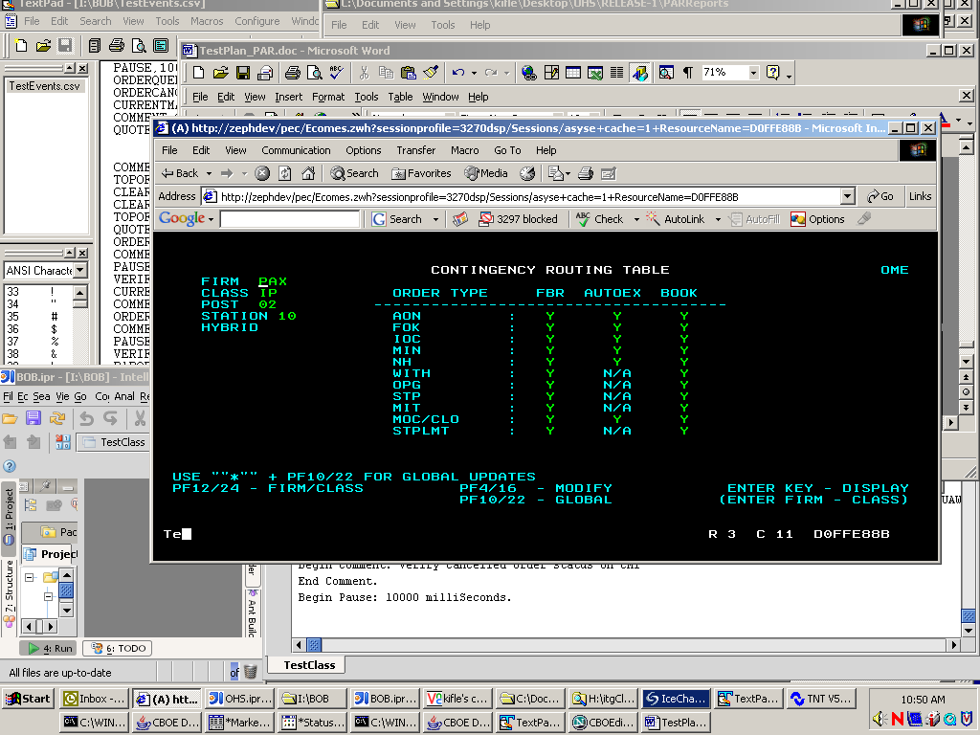

Menu 4 – F5 – Origin Routing Table
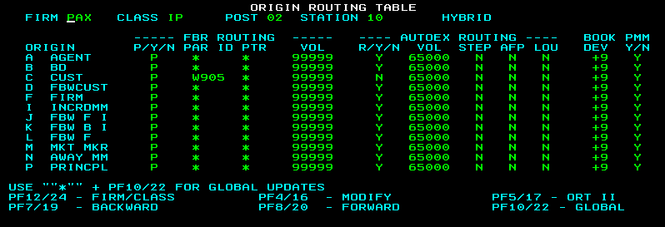
F5 again – Origin Routing Table (HAL routing settings)
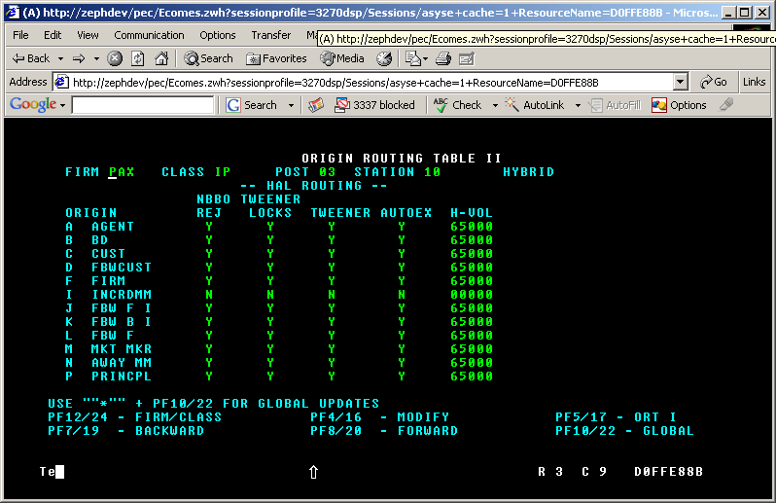

COMPLEX:
Menu4, F7, COMPLEX ORIGIN ROUTING TABLE
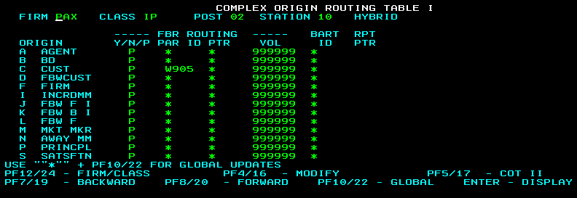
Menu4, F7, F5, COMPLEX ORIGIN ROUTING TABLE

